Linked Case Set: From Dogs to DNA

Overview:

Linked case sets are designed around a single model system or shared background. Each case in a set can have different learning outcome goals. The advantage of linked sets is that students can apply what they learn from one case to subsequent ones. Instructors benefit from not having to create and explain multiple independent sets of background and supporting data.

### Rationale For This Linked Set

The traditional approach to teaching genetics is to begin with dominant and recessive alleles as theoretical characteristics, and only later introduce the corresponding proteins. This approach confuses students for two reasons. First, the “formal to concrete” approach does not provide students with an intuitive scaffold on which to build long-term understanding. Second, treating inheritance patterns separately from the genes and proteins makes it harder for students to connect the two topic areas later.

In this series students learn how proteins might determine what a dog looks like or how it behaves, then work backwards to understand underlying genetics and inheritance patterns. Each scenario reinforces the link between the central dogma of molecular biology and classical genetic inheritance, rather than treating them separately.

This set has 3 previously unpublished cases from a larger linked set designed to teach 200-level undergraduate genetics and molecular biological principles using physical traits and behaviors of dogs. Links to the published cases from the set are in the References section.

**Case 1: That’s a Funny Looking Wolf**

Why do some dogs have curly coats, and others have straight coats?

**Case 2: Ask the Veterinarians**

How are visible physical traits inherited?

**Case 3: Dog Domestication & The “Friendly” Genes**

How can natural or artificial selection for one trait change many traits?

### Case 1: That’s a Funny Looking Wolf!

##### Central Question:

Why do some dogs have curly coats, and others have straight coats?

##### Objectives:

Students will learn or deduce that:

* In dogs, the most common phenotype (“wild type”) is a coat with, short straight hair.
* Curly hair is due to a mutation that creates a recessive allele.
* Heterozygous animals still can form normal straight hair.
* Hair is primarily made up of keratin proteins. How keratin protein molecules are arranged determines the structure of the hair (straight, wiry, curly.)

Advanced students who go deeper into this scenario will learn:

* A specific 1 bp mutation in the *KRT71* keratin gene changes how the protein arranges, and so how the hair grows.

##### Potential Pre-Case Questions:

These can be a formal pre-class assignment, or the instructor can ask them as they introduce the case.

1. What is hair made up of?
2. What is keratin? How is keratin structured?
3. How does a perm change a person’s hair from straight to curly? Why might hair become curly NATURALLY?
4. Given what it is made of, why do you think some animals have coat hair that is straight vs. curly? Long vs. short? Thick and wiry vs. thin and soft? How could you confirm your hypotheses?

##### Case Page 1:

Modern dogs are domesticated descendants of Eurasian wolves. Exactly where and how this happened is an ongoing debate. What is clear though is that dogs have changed a LOT since separating from the wolves. Look at the three photos on the next page.

1. **What are the physical similarities and differences between wolves and the two dog breeds shown?**
2. **Which of the differences you identified are genetically controlled? Which are not?**

|  |  |
| --- | --- |
| Northern European Wolf | |
|  | |
| Komondor (Hungarian herding dog) | Curly-coated retriever |
|  |  |

##### Case Page 2:

Two physical differences between wolves and dogs are the length of their coat and whether the hair is straight or curly. What we want to know is whether coat length and curliness are genetically controlled, and if the latter, how the two phenotypes are inherited.

Wolves, Komondors, and curly-coated retrievers are all “true-breeding,” meaning that they are isolated reproductively from each other, and that most of the genes are “fixed.” If you breed a male and female curly-coated retriever, all of their puppies will look the same as their parents and have short curly coats. The same is true for the wolves (straight medium coats) and Komondors (very long cord-like coats).

1. Suppose you hypothesize coat length and curliness are NOT genetically determined. What experiments could you do to test that hypothesis? What data or results would support your hypothesis?
2. Suppose you hypothesize coat length and curliness ARE genetically determined. What experiments could you do to test that hypothesis? What data or results would support your hypothesis?
3. Is there any evidence to suggest that coat length and curliness are controlled by the same gene? What is your reasoning? How would you demonstrate that coat length and curliness are controlled by the same gene (or different genes?)

##### Case Page 3:

Studies have shown that ca dog’s oat length, curliness, wiry texture, and “furnishings” (extra thick eyebrows and muzzle hair) are controlled by separate genes (Cadieu, 2009). The gene linked to curly hair codes for the Keratin 71 (KRT71) protein.

Wolves and dogs with straight-haired coats have the wild type allele for KRT71. Dogs with curly hair are homozygous (r/r) for a 1 bp change (C to T) in Exon 2 of KRT71. This single nucleotide polymorphism changes Arg-151 to Trp (R151W). As a result the hair does not grow straight, but curls instead. Dogs that are heterozygous (R/r) have straight hair.

1. Before you do any outside exploration, look at the mutation in KRT71. Think about how proteins form larger structures. How (in general) could this recessive mutation change hair from being straight to being curly? What could be happening at the level of DNA and proteins? (Don’t try to come up with the “right” answer; think about it and come up with logical hypotheses.)
2. Now go online and find out how keratins are arranged inside of hair. Summarize what you learn in a short paragraph or two and share it with your team.
3. Currently it is not known why the KRT71 mutation makes a dog’s hair curly.
4. Based on your earlier hypotheses (from Qu. #1) and what you learned about keratins (from Qu. #2), make 1-2 revised hypotheses for how/why the3 KRT71 mutation makes a dog’s coat curly.
5. How can you test the hypotheses you just made? What experiment(s) could you do? What data or evidence would you need to support your hypothesis?

#### Instructor Notes: Case 1

Hair in a dog’s coat is extremely similar to human hair so much of what students know already or discover about human hair will be relevant to dog coat hair too. The main differences are:

* A dog’s coat stops growing at a particular length, while human head hair (but not pubic hair) continues growing
* A dog’s coat is a mix of 2 or 3 hair types (down, awn, and guard hairs) while humans have 1 hair type per location on their body.

The pre-class questions are designed to get students thinking about the biochemical nature of hair. Because it is predominantly keratin, students can understand a great deal about how hair behaves by thinking about how proteins behave generally. The biochemistry of the constituent amino acids and their arrangement will also play a role in how hair behaves.

*Pre-Class Questions:*

1. **What is hair made up of?**

A single hair is a quite complex. It is roughly cylindrical, ranging from 10µm to 100µm in diameter. It has an outer layer or cuticle composed of plate-like, overlapping dead cells, and a fibrous inner cortex. Both regions contain tightly packed keratin filaments embedded in a gel-like matrix of intermediate filament associated proteins (IFAP), similar to the way fiberglass has fibers embedded in epoxy resin.

Hair fibers are 65-95% keratin protein by weight, with the remainder consisting of surface lipids, nuclear remnants, carbohydrates and some inorganic salts. Keratin is one of the intermediate filament proteins. Keratins in cells (cytokeratins) form filaments 10 nm in diameter. They are part of the desmosomes and hemi-desmosomes that anchor epithelial cells to each other and to extracellular matrix. Other keratins form nails, feathers, hooves, enamel, horns, and outer layers of skin.

This question comes back as part of Page 3 of this case.

1. **What is keratin? How is keratin structured?**

Dogs and humans both have >57 known keratin genes located in 2 clusters in their respective genomes. The keratins are subdivided into “soft” and “hard” types. Soft keratins are pliable molecules that break down easily. They are most common in skin. Hard keratins predominate in hair; they are resistant to proteolysis and more difficult to degrade in general. They are not mutually exclusive though; both soft and hard types can be mixed together in individual fibers to create a great range of functional properties.

All keratin proteins have a high percentage (~18%) of the sulfur-containing amino acid cysteine. At the molecular level, hydrophobic interactions make individual keratin molecules combine into coiled coils. Cystine disulfide bonds then link individual keratin monomers into larger chemically resistant structures.

1. **How does a perm change a person’s hair from straight to curly? Why might hair become curly NATURALLY?**

The goal of this question is to surface the concept that hair structure is not the result of just the chemistry of individual keratin molecules, but also due to how molecules are cross-linked into higher level structures.

Many students will know from life experiences that straight hair can be treated chemically so it remains curled. Chemicals used for perms (specifically thioglycolic acid or bisulfite) break the disulfide bonds temporarily. When they are inactivated, the C-C bonds reform, setting the hairs in a new curled shape. Students may try to use this bit of common knowledge to infer why hair is curly in general, and they will be **partially** correct. However this is not the primary reason hair curls.

It is not known precisely why hair is naturally curly, but best evidence indicates that overall geometry of individual strands is important. The diameter and shape of the hair shaft is determined by the shape of the follicle in the skin from which it grows. Large follicles produce coarse hair, and small follicles, fine hair. Flattened follicles grow hairs that are flattened into an oval. Flatter hair strands have more surface area for disulfide bond formation and can bend more as they emerge than hairs that are cylindrical.

1. **Why do you think some animals have coat hair that is straight vs. curly? Long vs. short? Thick and wiry vs. thin and soft? Are the traits randomly occurring, the result of genetic inheritance, or the result of physiological adaptations? How could you confirm your hypotheses?**

The goal of this question is to get students thinking about possible mechanisms and paths, not to come up with a correct answer. Most students should be able to deduce that hair patterns are genetically determined, based on their own lived experiences and prior knowledge. This is the main hypothesis that instructors need to lead students towards, because the main case focuses on the inheritance pattern of coat curliness.

More advanced students may hypothesize that hair length and texture are due to mutations in a keratin gene. This is a very reasonable and very testable hypothesis, even if it is only partly correct. Curliness is linked to a keratin mutation, but length and texture are regulated by other loci that can be inherited independently.

Students with more biochemistry background might hypothesize that hair texture is altered by mutations that change cysteines. Again this is a very reasonable and very testable hypothesis, even if it is not correct. The SNP that causes curly coats does not affect cysteines. Rather, the key mutation changes a basic amino acid (arginine) to a polar uncharged amino acid. Why the Arg151Trp mutation creates curly hair is not known, but it would be reasonable to hypothesize that the change in amino acid sequence affects protein organization and packing.

*Page 1 Questions:*

1. **What are the physical similarities and differences between wolves and the two dog breeds shown?**

This question helps students build a list of all the phenotypic variations that have developed through the selection process. The instructor or a class scribe should record their list of features on a whiteboard and provide a copy (print or online) as a point to return to for future discussion.

These are some of the visually obvious phenotypic differences:

* Wolves are very similar in size and relative proportions within a subspecies, and only experts can tell the subspecies apart. In contrast, dogs are clearly different from wolves, and many breeds are very distinctive from each other.
* Wolves have flat double coats that provide insulation from the cold while not being bulky. Pure breed dogs range in coat types and length.
* A wolf’s foot is much larger in proportion to its body size than a dog. The track print of an average size wolf is 50% larger than the largest Great Danes.
* At rest, a wolf’s ears are erect. Many domestic breeds have ears that hang down.

Other differences are not visible in photos:

* Wolves have a different gait than dogs. Wolves are said to “walk with a purpose,” meaning they walk in a straight line with rear and front feet aligned. Dogs tend to walk angled or even sideways, and their track path wanders much more.
* Both wolves and dogs communicate extensively through body posture, positions of their tails and ears, and scent. Both have a range of sounds they use for communicating in close proximity to each other. What is different is that wolves howl extensively and rarely bark, while dogs communicate by barking and howl much less.
  + In feral packs, dogs at home base will howl to orient others out scouting or hunting. This form of howling IS similar to what wolves do. It is thought that domestic dogs left alone howl to call back their pack members (i.e., owners).
  + Wolf packs howl to maintain territory boundaries with distant packs. Dogs may howl when intruders get close, usually in visual range.
  + Dogs may howl when anxious, bored, injured, or in pain. Wolves will not attract the attention of other predators, so do not howl when anxious or injured.

Some students may think the photo represents what all wolves look alike. Our shared mntal picture of wolves is based mainly on Mackenzie Valley gray wolves (*C. lupus occidentalis*) of western Canada and Alaska, tundra wolves (*C. lupus albus*) of the high Arctic, and Eurasian wolves (*C. lupus lupus; the subspecies in the photo*) of Turkey and the Russian steppes. All three are stocky, heavily built subspecies. Wolves native to temperate and desert areas are more gracile and smaller. If students want to know more about this, have them compare photos of Arctic wolves with photos of red wolves (*C. lupus rufus*) from the southeastern US, and Indian wolves (*C. lupus pallipes*) from the Middle East and western India. These latter two subspecies are better examples of what the wolve ancestors of primitive dogs probably looked like.

1. **Which of the differences you identified are genetically controlled? Which are not?**

This question is intended to stimulate thinking generally, not to obtain specific details. It also is meant to uncover a common student misconception about basic genetics. Essentially all differences between dogs and wolves, and between different breeds of dogs, are genetically determined by differences in either coding sequence or epigenetic markers. This includes most breed-specific behaviors (herding, pointing, retrieving), which basically are elements of the wolf’s stalk and kill behavioral sequence.

The better question which the instructor can ask as a follow-up is, “which differences are due to simple Mendelian inheritance, and which are more complex polygenic traits?”

*Page 2 Questions:*

1. **Suppose you hypothesize coat length and curliness are NOT genetically controlled. What experiments could you do to test that hypothesis? What data or results would support your hypothesis?**

Students are unlikely to think this, but it is a useful thought exercise. Often students look for confirming data, and forget that other hypotheses need to be ruled out. Here they are explicitly asked to plan an experiment to demonstrate non-genetic control.

1. **Suppose you hypothesize coat length and curliness ARE genetically determined. What experiments could you do to test that hypothesis? What data or results would support your hypothesis?**
2. **Is there any evidence to suggest that coat length and curliness are controlled by the same gene? What is your reasoning? How would you demonstrate that coat length and curliness are controlled by the same gene (or different genes?)**

Wolves have intermediate-length straight coats. The fact that Komondors have a long coat that is relatively straight while curly-coated retrievers have short curly coats could be interpreted to be caused by one gene change, but students’ own lived experiences will tell them that there are short-/straight-haired dogs (the most common coat phenotype). Observations suggest that the two traits are the result of different genes.

Both questions can be answered definitively using simple dihybrid crosses and looking for standard Mendelian inheritance patterns. Start by assuming that straight versus curly coat is controlled by just one gene, with two alleles (A, a), and coat length by a second with two alleles (B, b). The 3 types are true-breeding, so we can assume they are homozygous for one allele at each of 2 loci. Without knowing which allele is dominant, a cross of a curly-coated retriever to a Komondor could follow any of these patterns:

|  |  |  |  |  |  |  |  |  |  |  |
| --- | --- | --- | --- | --- | --- | --- | --- | --- | --- | --- |
| 2nd parent | 1st parent | |  | 2nd parent | 1st parent | |  | 2nd parent | 1st parent | |
| AB | AB |  | Ab | Ab |  | aB | aB |
| ab | AaBb | AaBb |  | aB | AaBb | AaBb |  | Ab | AaBb | AaBb |
| ab | AaBb | AaBb |  | aB | AaBb | AaBb |  | Ab | AaBb | AaBb |

All puppies should have a single coat phenotype that reflects the dominant trait(s). If puppies were crossed to produce an F2 generation, the two traits (curliness, length) should segregate almost completely. If they do not segregate, then one gene is likely controlling both traits.

*Page 3 Questions:*

1. **Before you do any outside exploration, look at the mutation in KRT71. Think about how proteins form larger structures. How (in general) could this recessive mutation change hair from being straight to being curly? What could be happening at the level of DNA and proteins?**

The goal of this question is to get students to develop a variety of testable hypotheses. Encourage broad thinking at this point; students will reduce their lists by the end of this page.

1. **Now go online and find out how keratins are arranged inside of hair. Summarize what you learn in a short paragraph or two and share it with your team.**

Encourage students working together to pick different resources, so the team or class has more data for making hypotheses.

1. **Currently it is not known why the KRT71 mutation makes a dog’s hair curly.**
2. **Based on your hypotheses from Qu. #1 & what you learned about keratins from Qu. #2), make 1-2 revised hypotheses for how a KRT71 mutation makes a dog’s coat curly.**
3. **How can you test the hypotheses you just made? What experiment(s) could you do? What data or evidence would you need to support your hypothesis?**

Once again, thinking process and experimental designs are more important than finding the right answer. As the case says, it is not known why this particular mutation leads to curly hair. Emphasize claims, evidence, and reasoning rather than finding the “right” answer.

### Case Structure and Course Management Notes

An embedded feature of these cases is student self-correction. By the end of each case students either work out the answers for themselves to open questions, or are given the right answers in a later part of the case. This means the instructor does not need to grade final assignments as closely. If students have completed the case assignments, they should have learned the key concepts. For example, early in Case 1 students must make hypotheses about whether coat length and curl are linked or separate genetically controlled traits. By the end of the case they will have learned this for themselves.

### Sources For More Information:

*Genetics of Dog Coat Length, Curl, and Furnishings*

Cadieu E, et al. 2009. Coat variation in the domestic dog is governed by variants in three genes. *Science*. 326(5949):150-3. doi: 10.1126/science.1177808.

<http://www.ncbi.nlm.nih.gov/pubmed/19713490>

*Keratins*

<http://www.genenames.org/cgi-bin/genefamilies/set/608>

<http://www.ncbi.nlm.nih.gov/pmc/articles/PMC2386534/>

<http://www.ncbi.nlm.nih.gov/pmc/articles/PMC2736122/>

*Hair Growth and Structure*

<http://www.rsc.org/Publishing/Journals/cb/Volume/2007/7/hair_is_the_news.asp>

<http://www.livescience.com/32104-what-makes-hair-curly.html>

<http://www.nature.com/jid/journal/v126/n11/fig_tab/5700532f1.html#figure-title>

Robbins C.R. 2012. *Chemical and Physical Behavior of Human Hair*, Berlin, Springer-Verlag. DOI 10.1007/978-3-642-25611-0\_2

### Photos and Illustrations

Wolf:

https://commons.wikimedia.org/wiki/File:Eurasian\_wolf\_2.jpg

Creative Commons Attribution-Share Alike 4.0 International license

Komondor:

https://upload.wikimedia.org/wikipedia/commons/8/8b/Komondor\_delvin.jpg

Creative Commons Attribution 2.5 Generic license

Curly-coat retriever:

https://commons.wikimedia.org/wiki/File:Curly\_Coated\_Retriever.jpg

Creative Commons Attribution-Share Alike 3.0 Unported license

### Case 2: Ask the Veterinarians

##### Central Question:

How do single genes produce unusual or disease-related phenotypes?

##### Objectives:

Students will learn that:

* Differences in canine leg length can be caused by a single gene.
  + A mutant allele causes foreshortened legs
  + The mutant allele is autosomal dominant
  + A similar condition called achondroplastic dwarfism occurs in humans but is caused by a different mutation. One phenotype is due to different genotypes.
  + Students who choose to go deeper will discover that the abnormality in dogs is due to abnormal expression of *FGF4*
* Presence or absence of hair is controlled in certain breeds by a single gene.
  + Hairless is dominant, but never homozygous
  + The mutation is homozygous lethal
  + Only heterozygotes and wild type puppies survive past the embryo stage
  + Students who choose to go deeper will discover hairlessness is caused a mutation in the *FOXI3* developmental regulator gene.

##### Potential Pre-Case Questions:

These can be a formal pre-class assignment, or the instructor can ask them as they introduce the case.

1. What is a designer dog? How is it different from a pure breed dog?
2. Why are dogs good models for certain human diseases?
3. What is the difference between genotype and phenotype?
4. Can many genotypes produce the same phenotype? Can one genotype produce many phenotypes?

##### Case Page 1:

Back in February you landed a summer internship working in your university’s Public Relations Office. Now it’s 7 am on Tuesday after Memorial Day, and your first day on the job. Tina Lussa is the internship supervisor, and is telling you and your new co-workers what you’ll be doing.

“So each of you will be rotating through the various working groups, spending about 2 weeks getting to know what they do. Each rotation has a project…a bit unusual…work through… details…wits…”

You are still not used to being up this early, and it’s hard to stay focused. You figure you’ll get the hang of things as time goes along.

Your drifting attention snaps back when Ms. Lussa calls your name.

“You’ll do your first rotation with Community Communications. Your individual assignment these first two weeks is fielding questions posted on the Veterinary School’s new ***Ask the Vets*** blog.”

“The site is brand new, so you should not have too many serious cases. Medical issues get referred to the consulting vets. For non-medical questions, you have to come up with a reasonable and factually accurate answer to these on your own first, write it up so a non-specialist can understand it, then submit it to your supervisor for approval before you post the response back on the web.”

So **that’s** what she was saying when you drifted off!

*Questions:*

1. What kinds of questions do you anticipate blog viewers will have?

2. Where do you think you will need to go to find factually accurate answers to non-medical questions about dogs?

##### Case Page 2:

It’s Wednesday morning, and you log onto ***Ask the Vets*** to see what questions you can refer over to the veterinarians on call, and what questions you can answer. After sorting them, you have two that you think you can handle.

***Blog Post #1:***

Dear Ask the Vets:

We have a Welsh corgi named Hopkins. We love how brave and bold he is, but honestly he’s so short he gets underfoot and trips us. Our friends have an Australian kelpie called Sadie. For a couple years we’ve talked about breeding the two to create a new designer dog breed called a Torgi (tall Corgi). We figure other people might want a taller corgi too.

**Hopkins Sadie**

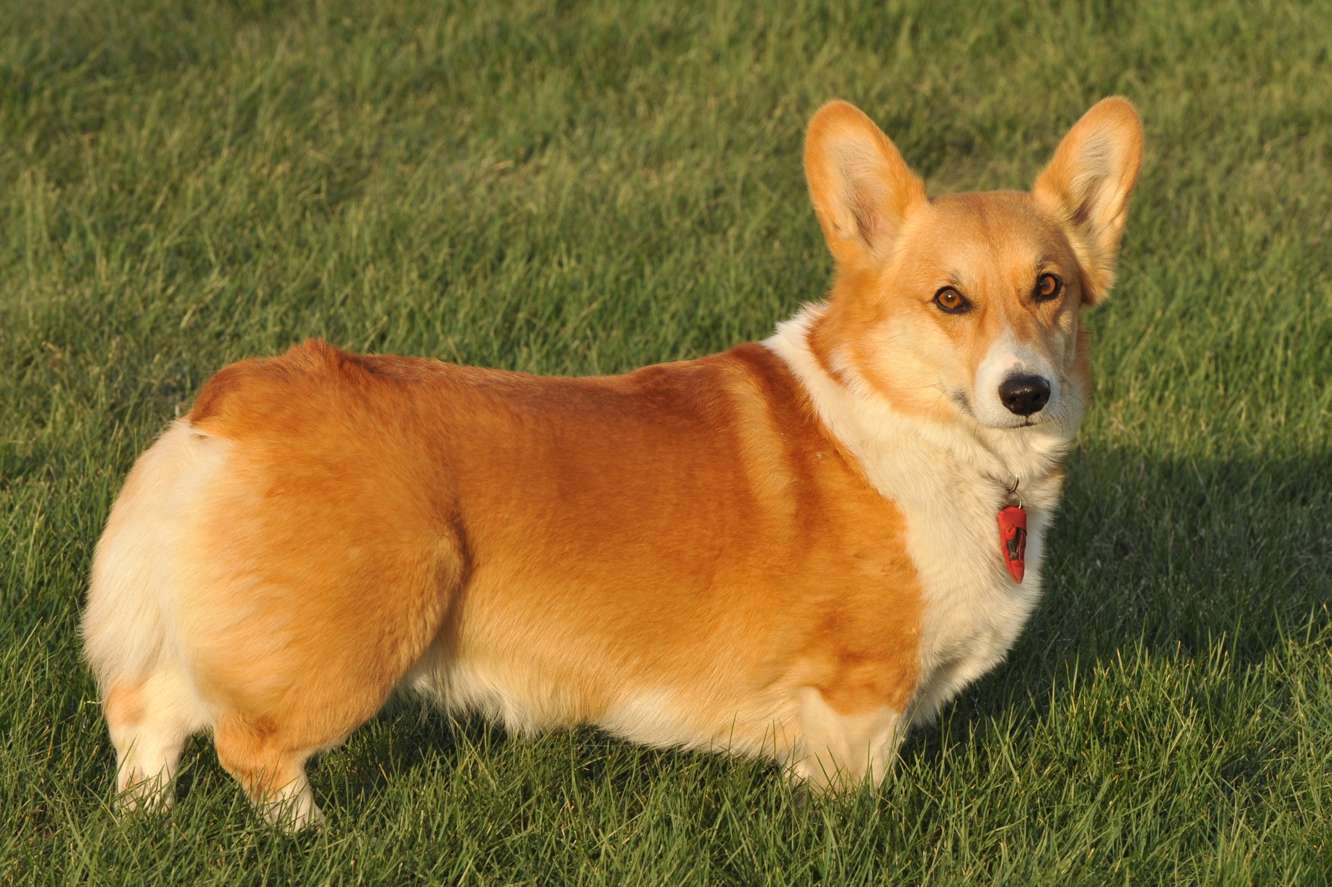 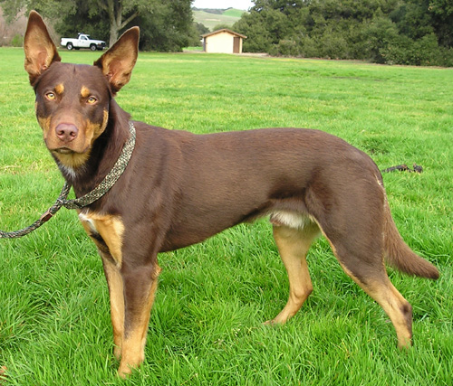

We bred Hopkins and Sadie twice but were disappointed both times. All 6 of their puppies in the first litter and 5 in their second had short legs. Not one of them turned out any taller than Hopkins is!

**Puppy from first litter Puppy from second litter**

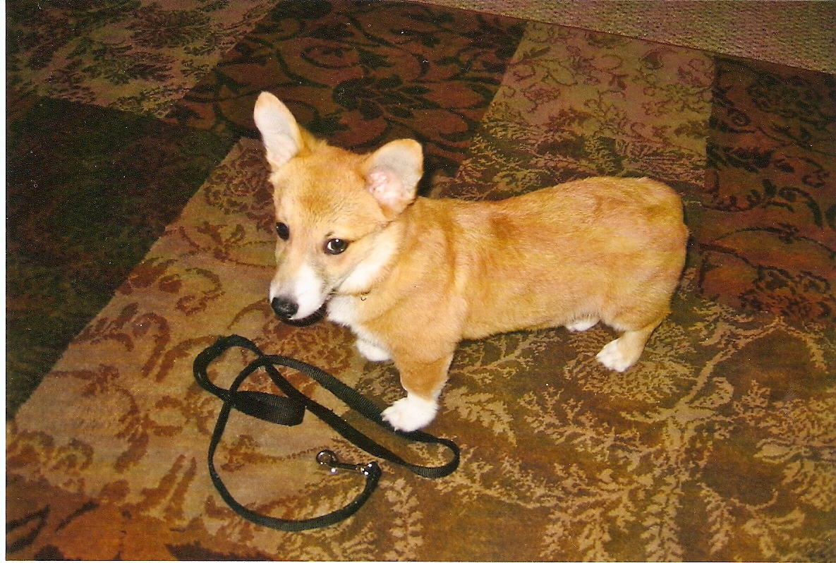 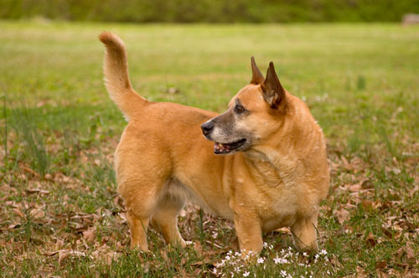

All of their puppies were adopted out to great homes, but we wonder if we should keep trying. Is it even possible for Hopkins and Sadie to have taller puppies?

*Questions:*

1. Look at Hopkins’ phenotype.

a. What specifically are his owners hoping to change?

b. What diseases or conditions you have seen in humans or other animals does his phenotype resemble?

1. Go out on the web and look for information about the diseases or conditions you identified. Look specifically for what mutations cause them, and how they are inherited.
2. Now look at the phenotypes of the puppies. Based on the data you have from the owners, and the Mendelian rules of inheritance, what can you hypothesize about how the phenotype is inherited?
3. Based on what you have learned, how will you respond back to Hopkins’ owners on the *Ask the Vets* blog? Write the response you will send to your supervisor.

##### Case Page 3:

***Blog Post #2:***

Dear Ask the Vets:

Our son is allergic to pet dander, but when he was young begged for a dog. So we got a Xoloitzcuintli, which is a Mexican hairless dog. Monty (short for Montezuma) looked strange, but he was so intelligent, sensitive, curious, and family-oriented that we all fell in love with him. Our son is on his own now, and Monty lives with him. My husband and I decided to start keeping and breeding Xolos. We have 3 right now: Lucy, Rico, and Baja.

**Monty Our current trio (L to R): Rico, Baja, and Lucy**

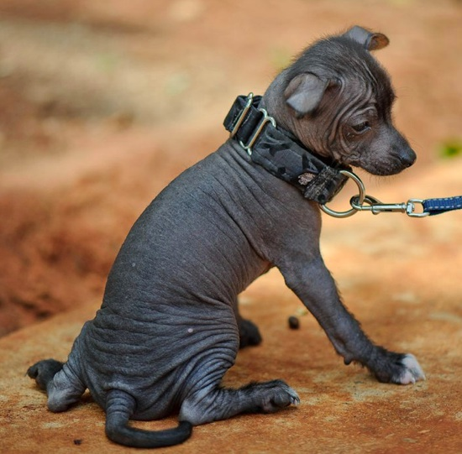 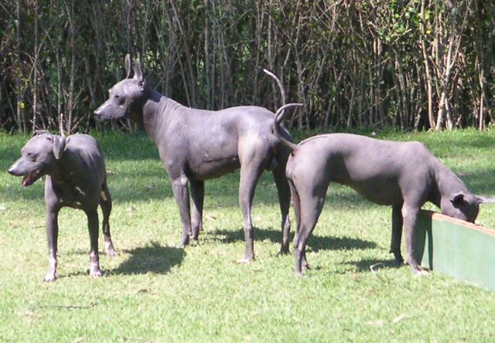

Here is our problem. We bred Lucy and Rico, and about a third of the pups had full coats. We thought a neighbor’s dog jumped the fence, so the next time Lucy went into heat we had our local vet artificially inseminate her, this time using Baja as the donor. Again we got a mix: 6 hairless pups (4 boys, 2 girls), and 3 pups with coats (1 boy, 2 girls). Here are **two dogs from our second litter**.

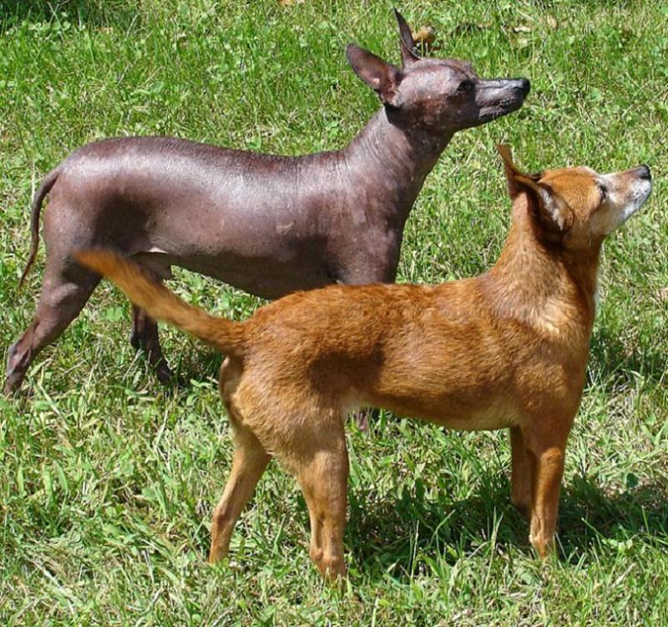

What is happening? Lucy came from a reputable breeder. Is she not a pure breed like we were told?

*Questions:*

1. Hairlessness is a rare phenotype in mammals. So we can assume for the moment that it is due to a single mutation. Now look at the phenotypes of Lucy’s puppies. Based on Mendelian rules of inheritance, what are ALL the possible combinations of genotypes that could produce the observed phenotypes?
2. Based on Question #1, which of the crosses you just worked out would be the most LIKELY explanation for what the Xolo owners are seeing? What is your reasoning?
3. Xolos are a very old breed that was sacred to several Central American cultures. Hairless dogs are mentioned in historic records from Mexico and Central America going back at least 3000 years. The same records also indicate that Xolos have always given birth to a mix of hairless and coated puppies.
4. Given what you know about how breeds are created, and about artificial selection for traits, how is this possible?
5. Could this explain what the owners of Lucy, Rico, and Baja saw?
6. Based on what you have learned, how will you respond back to Lucy’s owners on the *Ask the Vets* blog? Write the response you will send to your supervisor for approval.

#### Instructor Notes: Case 2

This scenario consists of 2 blog posts to which students must respond. Additional posts can be created on the same basic model. Once again students must evaluate phenotypes, but now they must use additional evidence to uncover the specific genotypes. Students also will start to look for parallels with human diseases and conditions.

The case scenarios stop short of providing a complete answer to the mystery. This time students can find the actual molecules responsible for the genotypes in each story by searching online. The instructor may assign this as an outside research project or follow-up activity.

Each blog post is designed to be a separate guided discussion. Students should work through them in class so the instructor can provide them with additional information as the discussions progress. Discuss the two posts in order: the thinking process that students learn while discussing the first post is very helpful for the second post.

As with Case 1, students should write responses to questions about the content of the pre-class videos BEFORE they view them.

Each of the posts also requires students to respond back to the dog owners in lay terms. Ideally students should turn in **individual** responses as a homework assignment. This serves two purposes. First, their answers will show how well they understood the day’s discussion and provides some individual accountability. Second, it reinforces learning through delayed recall and elaboration.

*Pre-Class Questions:*

1. **What is a designer dog? How is it different from a pure breed dog?**

Pure breed and designer dogs are recent developments in the evolutionary history of dogs, and both are the result of human intervention. To understand why, look at the four so-called “primitive dogs:” African village dogs, Canaan (aka desert) dogs, Indian pariah dogs, and Carolina dogs. These are true dogs, not hybrids with wolves or other canids. It is generally accepted that these represent the most primitive forms of dogs, and are probably similar to the earliest domesticated dogs. Now look at the photos. below Even though the populations are geographically separated, these dogs from different part of the world look surprisingly similar. In the absence of any direct human intervention, dogs are not particularly selective about their mates. Genes are constantly mixing within local populations and moving between adjacent populations of primitive dogs, leading to similar phenotypes.

This is where human intervention and selection become important. Pure breed dogs come from closed breeding population that humans have established and maintain by artificially selecting for desirable traits associated with that specific breed. Without human intervention, it is very unlikely that distinct dog breeds would ever have developed.

|  |  |
| --- | --- |
| African village dogs (4 images) | |
| Macintosh HD:Users:danjohnson:Dropbox:NCCSTS Flipped Case:Photos:4-walking-to-vaccination.jpg | Macintosh HD:Users:danjohnson:Dropbox:NCCSTS Flipped Case:Photos:1-boywith-herding-dog.jpg |
| Macintosh HD:Users:danjohnson:Dropbox:NCCSTS Flipped Case:Photos:african-village-dogs.jpg | Macintosh HD:Users:danjohnson:Dropbox:NCCSTS Flipped Case:Photos:cdv-10-011.jpg |
| Indian pariah dog | Canaan dog |
| Macintosh HD:Users:danjohnson:Dropbox:NCCSTS Flipped Case:Photos:The_Indian_Pariah_Dog.jpg | Macintosh HD:Users:danjohnson:Dropbox:NCCSTS Flipped Case:Photos:CanaanDog3.jpg |

|  |  |
| --- | --- |
| Carolina dogs (L and R) | |
| Macintosh HD:Users:danjohnson:Dropbox:NCCSTS Flipped Case:Photos:Carolina_dog_3-13-13.jpg | Macintosh HD:Users:danjohnson:Dropbox:NCCSTS Flipped Case:Photos:Carolina_Dog_1.jpg |

Primitive dogs are similar to each other because they are highly outbred, and share a fully open gene pool. Pure breed (short for pure breeding) dogs produce offspring that are essentially the same as the parent because they come from small closed populations, or “closed blood lines.” Dogs are selected that meet a particular set of standards, and only bred to each other. No dogs from outside the closed population can contribute genetic information to the breed gene pool. The dogs are inbred until their genotypes are “fixed.” This eliminates any genetic variation that could produce phenotypes outside the desired norm.

Pure breeds are a very recent development in canine evolutionary history. There are perhaps two dozen or so loose “proto-breeds” that can be traced back 3000 to perhaps 4000 years, but they were not strict pure breeds by the above definition. They simply were the preferred types of dogs for a given region, ethnic group, or task.

A few of the formally recognized breeds we know today can be traced back to the 1600s, when the blood lines were closed and only dogs meeting the “breed standards” were allowed to carry the name of “pure breeding.” The great majority of modern breeds though were established by Victorian Europeans in the 1800s.

Breeders continue to tinker with dogs, and some continue to develop new breeds. A bigger trend in recent years has been to create “designer dogs.” Accidental matings between two different types of dogs produces a hybrid, also known as a mutt, mongrel, or mixed breed. Designer dogs are produced by intentionally breeding two formerly isolated breeds to combine their desirable traits, then interbreeding the progeny to create a new intermediate breed.

Unlike pure breed dogs, most designer dogs have not been back-crossed enough times to fix all alleles. Crossing designer dogs can produce some surprisingly different puppies, especially if:

* The parents of the puppies are F1 offspring of pure parents, or
* The breeds of the pure parents have been separated for a long time or are very different physically.

Some more popular designer dogs include:

|  |  |
| --- | --- |
| **Name** | **Parents** |
| Airedoodle | Airedale Terrier / Poodle |
| Bagle Hound | Basset Hound / Beagle |
| Baskimo | American Eskimo / Basset Hound |
| Bullmatian | Bulldog / Dalmatian Hybrid |
| Bully Basset (Bullet) | Basset Hound / Bulldog |
| Cadoodle | Collie / Poodle |
| Chiweenie | Chihuahua / Dachshund |
| Dorgi | Corgi / Dachshund |
| Dorkie | Dachshund / Yorkie |
| Goldendoodle | Golden Retriever / Poodle |
| Great Pyredane | Great Dane / Great Pyrenees |
| Labradoodle | Poodle / Labrador retriever |
| Puggat | Pug / Rat Terrier |
| Raggle | Rat Terrier / Beagle |
| Saint Weiler | Rottweiler / Saint Bernard |

1. **Why are dogs good models for certain human diseases?**

Shared evolutionary history: dogs have co-evolved with humans for at least 38,000 years. Because we both are mammals, natural selection has favored similar solutions to similar survival challenges.

Similar environments: dogs spend most of their lives in close proximity to their owners. We breathe the same air, and are exposed to the same radiological, biological, and chemical hazards.

Similar diet: marketing claims aside, the average dog’s diet is very similar to ours. Animal feed and prepackaged food for human consumption are made with many of the same ingredients produced and sold by the same suppliers.

Highly inbred populations: dogs are particularly useful for locating genes linked to disease. Currently over 450 dog breeds are known, each a separate closed breeding population. When some breeds are predisposed to a particular disease or condition but other breeds not, researchers can identify candidate genes by comparing the genomes of the two groups. These “genome-wide association scans” have helped us identify several candidate disease genes. For example, studies conducted on a colony of narcoleptic dachshunds and Doberman pinschers at Stanford University led to the discovery of the hypocretin/orexin receptor, which is central to arousal and sleep regulation, and has been implicated in narcolepsy (Lin, 1999).

1. **What is the difference between genotype and phenotype?**

Genotype is the actual sequence of bases in the DNA at a particular locus. In general genotype is fixed for an organism. Unless there is a spontaneous mutation, the DNA sequence corresponding of a particular genotype is either present or absent; there is no middle ground.

While phenotype is determined by genotype, phenotype is much more complex. Some phenotypes are as clear-cut as genotype. Examples of unambiguous binary phenotypes that either are present or absent include the presence or absence of a widow’s peak in a person’s hairline, presence or absence of the hitchhiker’s thumb, or any of the other traits students learn about in an introductory genetics lab. In these cases the underlying alleles are simply dominant or recessive, and phenotype depends on whether an organism is homozygous dominant, heterozygous, or homozygous recessive. Other genotypes display incomplete or co-dominance; in these cases, homozygotes and heterozygotes have different phenotypes. Some phenotypes are the result of multiple genes. A good example of this is eye color. It was long thought that blue eyes in humans was a simple recessive allele. We know now that eye color is controlled by multiple genes.

Still other genotypes produce a basic phenotype, but that phenotype varies depending on the organism’s environment. For example, dogs have curly coats when they are homozygous for a recessive allele of the *KRT71* gene. How tightly curled the dog’s coat is though depends on other genes, and the environment. A dog in a hot climate might never grow a winter coat, and so would never display a heavily curled coat. Instead its coat might appear wavy or rumpled.

1. **Can many genotypes produce the same phenotype? Can one genotype produce many phenotypes?**

Any number of different genotypes can produce a similar phenotype. There is an excellent example of this in fruit flies (*Drosophila melanogaster*). Most students learned in high school that white eyed mutant flies carry an X-linked gene. What most do NOT know is the cause of the phenotype, and that other genotypes produce this same phenotype.

* The sex-linked white eye mutant they have seen in school is a mutation in a transporter protein encoded by a locus on the X chromosome. The encoded protein transports 2 pigments (red and brown) to their final positions in the eyes.
* Flies that are homozygous for two inactivating mutations, one in the red pigment pathway, the other in the brown pigment pathway, will have white eyes too. The Bloomington Drosophila Stock Center maintains many different fly lines with white eyes. The lines have different genotypes, all producing the same white-eye phenotype.

The point is not for students to know details of fly eye pigments and pathways. Rather that they understand the same phenotype (here, lack of eye pigment) can be due to more than one genotype.

*Page 1 Questions:*

* 1. **What kinds of questions do you anticipate blog viewers will have?**
  2. **Where do you think you will need to go to find factually accurate answers to non-medical questions about dogs?**

The goal of both questions is the same, which is to get students thinking about where they might find factually accurate answers to dog-owners’ questions.

*Page 2 Questions for Blog Scenario 1:*

1. **Look at Hopkins’ phenotype. What specifically are his owners hoping to change? What diseases or conditions you have seen in humans or other animals does his phenotype resemble?**
2. **Go out on the web and look for information about the diseases or conditions you identified. Look specifically for what mutations cause them, and how they are inherited.**

Normally, a dog has limbs that are about the same length as their torso from base of the neck to base of the tail. Hopkins has limbs that are shorter than normal for his body. Foreshortened limbs with an otherwise normal body size are characteristic of dwarfism in humans and several other mammalian species.

More than 300 medical conditions can lead to dwarfism. Achondroplastic dwarfism (ACPD) is one of the most common forms. In humans it is caused by a mutation in fibroblast growth factor receptor 3 (FGFR3). Normally, FGFR3 inhibits bone growth, so a mutation that constitutively activates the receptor blocks normal bone growth. A single copy is needed to retard growth, so human ACPD is inherited as an autosomal dominant allele.

At first, it would seem that a similar mutation has occurred in dogs. However, as part of outside research, students will learn that the FGFR3 mutation that occurs in humans is homozygous lethal. If they do not, the instructor should share or lead them to this information.

1. **Now look at the phenotypes of the puppies. Based on the data you have, and the Mendelian rules of inheritance, what can you hypothesize about how the phenotype is inherited?**

Pure breed dogs come from closed breeding lines. If a corgi was heterozygous for an FGFR3 mutation, it could produce some longer-legged puppies (a fact that becomes important in the next posting). Based on this and the inheritance pattern from Qu. #3, students should be able to deduce that it is impossible for corgis to have a mutation in FGFR3.The only way to produce all puppies with short legs is if the mutation is in a different locus. This is in fact what has happened. Given that all 14 puppies have foreshortened legs, it is likely due to an autosomal dominant mutation.

1. **Based on what you have learned, how will you respond back to Hopkins’ owners on the *Ask the Vets* blog? Write the response you will send to your supervisor.**

They are unlikely to ever be successful. Best if the owners enjoy the dog they have.

*Additional Background*

Corgis are one of several breeds that are homozygous for an FGF4 retrogene. Overproduction of FGF4 produces the same **phenotype** as a constitutively active FGFR3, but the FGF4 retrogene is not homozygous lethal. Although not proven, a reasonable speculation would be that FGF4 acts at least partly FGFR3 receptor.

The FGF-4 retrogene is located on CFA 18. Other breeds that have the retrogene include the Basset hound, Cairn terrier, Dachshunds, Pekingese, Scottish terrier, Shih tzu, Swedish valhund, and West highland terrier. Long legged dogs and large breeds cannot be silent carriers of this mutation; if the allele is present, a dog has short legs. Parker (2009) describes how this defect probably arose originally.

*Page 3 Questions for Blog Scenario 2:*

1. **Hairlessness is a rare phenotype in mammals. So we can assume for the moment that it is due to a single mutation. Now look at the phenotypes of Lucy’s puppies. Based on Mendelian rules of inheritance, what are ALL the possible combinations of genotypes that could produce the observed phenotypes?**

If we make no assumptions about whether hairlessness is dominant or recessive we must try all possible options. For two alleles, named H (dominant) and h (recessive), these are the only crosses that create 2 distinct phenotypes. The remaining two crosses (HH x HH, and hh x hh) do not need to be considered, because the question is whether Lucy is not a pure breed Xolo.

Students might suggest that Lucy is pure but Baja and Rico are homozygous. For an autosomal allele, the gender of the parents makes no difference. Nevertheless, the outline below of the crosses accounts for this possibility.

|  |  |  |  |  |  |  |  |  |  |  |
| --- | --- | --- | --- | --- | --- | --- | --- | --- | --- | --- |
| ONE | 1st parent | |  | TWO | 1st parent | |  | THREE | 1st parent | |
| 2nd parent | H | H |  | 2nd parent | H | h |  | 2nd parent | H | h |
| H | HH | HH |  | H | HH | Hh |  | h | Hh | **hh** |
| h | Hh | Hh |  | h | Hh | **hh** |  | h | Hh | **hh** |

**Cross One:** Lucy is heterozygous Hh ; Baja and Rico are homozygous dominant HH (or, Lucy is HH and Baja/Rico are Hh). Hairlessness is dominant, so NONE of the puppies could have hair. This cross cannot explain the observed phenotypes. So based on logic alone we can eliminate Cross One.

**Cross Two:** Lucy, Baja and Rico are all heterozygous Hh. If hairlessness is dominant, three puppies in four should be hairless, and one in four should have a coat. If hairlessness is recessive, three puppies in four should have hair, and one in four no hair.

**Cross Three:** Lucy is heterozygous Hh; Baja and Rico are homozygous recessive hh (or, Lucy is hh and Baja/Rico are Hh). Half the puppies should be hairless, half should have a coat.

The other possibility students might suggest is that hairlessness is X-linked. This is reasonable given that sex-linked alleles present differently depending on the sex of the parental carrier and the offspring. If students once again make no assumption about whether hairlessness is dominant or recessive, and set up all possible crosses:

If hairlessness is X-linked dominant X-linked recessive

|  |  |  |  |  |  |  |  |  |  |  |
| --- | --- | --- | --- | --- | --- | --- | --- | --- | --- | --- |
| FOUR | Rico & Baja | |  | FIVE | Rico & Baja | |  | SIX | Rico & Baja | |
| Lucy | XH | y |  | Lucy | XH | y |  | Lucy | Xh | y |
| XH | XHXH | XHy |  | XH | XHXH | XHy |  | Xh | XhXh | Xhy |
| XH | XHXH | XHy |  | Xh | XHXh | **Xhy** |  | Xh | XhXh | Xhy |

**Crosses Four and Six** only produce hairless dogs. **Cross Five** can produce mixed litters of hairless and hairy puppies. However only the male puppies would have fur. Since puppies of both sexes had coats in the F1 generation, the hairless allele cannot be X-linked.

1. **Based on Question #1, which of the crosses you just worked out would be the most LIKELY explanation for what the Xolo owners are seeing? What is your reasoning?**

**Crosses One, Four, and Six** cannot produce two coat types. **Cross Five** can theoretically produce a mixed litter, but does not match the sex information that the owners provided. Both **Crosses Two and Three** could theoretically produce a mix of puppies with and without coats. However **Cross Three** should produce about equal numbers of hairless and coated puppies.

Process of elimination leaves **Cross Two** as the most likely pattern. That means ALL THREE dogs must be heterozygous.

1. **Xolos are a very old breed that was sacred to several Central American cultures. Hairless dogs are mentioned in historic records from Mexico and Central America going back at least 3000 years. The same records also indicate that Xolos have always given birth to a mix of hairless and coated puppies.**
2. **Given what you know about how breeds are created, and about artificial selection for traits, how is this possible?**
3. **Could this explain what the owners of Lucy, Rico, and Baja saw?**

Students have a hint as to the cause of the inheritance pattern in the original blog post. In the second litter, 6 of 9 pups were hairless, and 3 of 9 had coats. We see a 2:1 PHENOtype ratio when heterozygotes are crossed, and either the homozygous dominant or recessive is lethal. If the homozygous recessive was lethal, and only genotype HH and Hh dogs survived, there would be no puppies with the homozygous recessive PHENOtype. If the homozygous dominant is lethal, then we see two genotypes (Hh, and hh) and two phenotypes (hairless and coated).

Breeds are created by selecting a small pool of animals with the desired traits, and inter-breeding them until the desired traits are fixed. This never occurred in Xolos, because the desired mutation is homozygous lethal. The only way to maintain the mutation is as a heterozygote.

1. **Based on what you have learned, how will you respond back to Lucy’s owners on the *Ask the Vets* blog? Write the response you will send to your supervisor for approval.**

This inheritance pattern is normal for the breed.

*Additional Background*

Xolos are a well-documented historical example of how founder mutations ultimately become defined breeds. Molecular analysis indicates the mutation arose about 4,000 years ago. Historical records describing Xolos indicate they have been a recognized breed in Mexico for more than 3000 years.

Their hairlessness is controlled by the F locus, which contains the *FOXI3* gene on CFA 17. The exact function of FOXI3 is unknown, but other proteins in the FOX family control embryonic development in mammals. The orthologous gene in mice regulates development of teeth and fur cells.

The hairless allele is a 7 bp duplication in Exon 1 of the *FOXI3* gene. The allele is inherited as an autosomal semi-dominant. Homozygous embryos (F/F) for the mutation die in utero. A Mexican hairless dog is a heterozygote (F/f), and its short-haired littermate is homozygous recessive (f/f).

The mutation was intentionally introduced into two other breeds, the Peruvian hairless and Chinese crested dog. All three breeds all have the same mutation, and all three have both hairless and coated varieties. For further information see Drögemüller (2008).

### Photos and Illustrations

* Hopkins the corgi  
  <https://commons.wikimedia.org/wiki/File:Welchcorgipembroke.JPG>
* Sadie  
  <https://commons.wikimedia.org/wiki/File:Australien_Kelpie.jpg>
* Their Two Puppies  
  <https://commons.wikimedia.org/wiki/File:CardiganCorgi_Sue.jpg>   
  <https://commons.wikimedia.org/wiki/File:Young_dorgi.jpg>
* Monty the Xolo  
  <https://en.wikipedia.org/wiki/File:Toy_Xoloitzcuintli_Puppy.jpg>
* Lucy, Rico, Baja  
  <https://en.wikipedia.org/wiki/File:Mexico.Xoloitzcuintle.01.jpg>
* Two Xolo Puppies  
  <https://commons.wikimedia.org/wiki/File:Hairless_and_coated_half.JPG>
* African village dogs  
  <https://retrieverman.files.wordpress.com/2012/01/african-village-dogs.jpg>  
  <https://blogafya.files.wordpress.com/2013/09/1-boywith-herding-dog.jpg>  
  <https://blogafya.files.wordpress.com/2013/09/4-walking-to-vaccination.jpg>  
  <https://dianabuja.files.wordpress.com/2010/08/cdv-10-011.jpg>
* Canaan dog  
  <https://commons.wikimedia.org/wiki/File:CanaanDog3.jpg>
* Indian pariah dog  
  <https://commons.wikimedia.org/wiki/File:The_Indian_Pariah_Dog.jpg>
* Carolina dogs  
  <https://en.wikipedia.org/wiki/Carolina_Dog#/media/File:Carolina_Dog_1.jpg>  
  <https://commons.wikimedia.org/wiki/File:Carolina_dog_3-13-13.jpg>

### Case 3: Dog Domestication & The “Friendly” Genes

##### Central Question:

How can natural or artificial selection for one trait change many traits?

##### Objectives:

Students will learn that:

* One theory for how dogs were domesticated is that selection favored wolves that were not afraid of humans.
* During a Russian breeding experiment with foxes, selection for friendliness also produced changes in coat colors, tail shape, body structure, and behaviors.
* Changes in one metabolic pathway could potentially explain the suite of phenotype changes that eventually led to dogs.

##### Potential Pre-Case Questions:

These can be a formal pre-class assignment, or the instructor can ask them as they introduce the case.

1. How are species domesticated? What is the **process** by which it happens?
2. We know that some phenotypes tend to occur together.
   1. Why does it happen?
   2. What is happening at the level of DNA?
3. What is domestication? How much do organisms change during domestication?
4. Why does one selection event bring others along with it?

#### Case Handouts:

##### Case Page 1:

Think about what wolves look like, and how they behave. Then think about what a typical dog **looks** like, how it **behaves**, and the **variety** of different phenotypes dogs have.

1. What are the differences between wolves and dogs? How are they similar?
2. Which of these differences are genetically controlled? Which are not?
3. How many mutations do you think are needed to make a phenotypic change?

|  |  |
| --- | --- |
| Wolves | |
| Wolf_dierenrijk_2009.JPG | Lobo_en_Kolmården.jpg |
| Examples of “Primitive” Dogs | Two Examples of “Modern” Breeds |
| Macintosh HD:Users:danjohnson:Dropbox:NCCSTS Flipped Case:Photos:The_Indian_Pariah_Dog.jpg | Great Dane and Chihuahua.gif |
| Macintosh HD:Users:danjohnson:Dropbox:NCCSTS Flipped Case:Photos:CanaanDog3.jpg |

##### Case Page 2:

We know from many different sources of evidence that dogs split off from wolves around 40,000 years ago. Evidence published in 2015 suggests dogs are descended from a sub-species of Eurasian wolves that has since gone extinct. What we still do not know yet is exactly HOW wolves became domesticated.

*Questions:*

1. Imagine for a moment that you are a member of a small hunter-gatherer clan living in central Asia 40,000 years ago. Why would you want to domesticate wolves?
2. How would you start the process?

##### Case Page 3:

One hypothesis for how dogs were domesticated is the “camp wolf hypothesis.” According to this hypothesis, humans did not intend to domesticate wolves. The process began accidentally.

Wolves are excellent predators but will scavenge food from carcasses if it is available. Prior to domestication, wolves began scrounging in garbage dumps near human camps. Wolves that ran immediately when humans approached did not get as much to eat as wolves that did not run right away. Non-fleeing wolves ate more, and had more offspring, some of which inherited the alleles responsible for their parents’ calmer, “non-fleeing” phenotype.

The main source of evidence for this theory is a Russian breeding experiment with silver foxes. The original goal was to produce tamer foxes for the fur trade. The following videos describe the original experiment and its surprising outcomes. (Each link is a different source for the same story.)

* Dogs Decoded
  + <http://topdocumentaryfilms.com/dogs-decoded/>
  + Original NOVA site: <http://www.pbs.org/wgbh/nova/nature/dogs-decoded.html>
  + To purchase: <http://www.amazon.com/Nova-Dogs-Decoded/dp/B0040QYRS6>

*Questions:*

1. How did the breeders identify foxes with a less fearful phenotype?
2. What other phenotypes appeared when the research team selected for lack of fear?
3. What are your hypotheses for WHY these secondary phenotypes appeared? Why are they linked to lack of fear?
4. Look at the “domesticated” foxes created during this experiment. Do they all have the same phenotype, or do they have different phenotypes? Based on what you see, how do you explain that primitive dogs all have very similar same phenotypes?
5. Based on the evidence described in the video, what was the FIRST genetic change that triggered the other changes required for domestication?
6. If all primitive dogs have similar phenotype, how do you explain the development of different types and breeds of dogs?

##### Case Page 4:

The figure below shows two paths that mammals use to convert essential amino acids into other important molecules. Use the Legend to orient yourself.

Macintosh HD:Users:danjohnson:Desktop:Amino Acid Metabolism.pdf

*Questions:*

1. What are essential amino acids? What are the primary sources of essential amino acids in human and canid diets?
2. Based on these pathways, what are the main products that organisms produce from the amino acids phenylalanine and tryptophan?
3. Which (if any) of the molecules produced from phenylalanine or tryptophan metabolism might be linked to the “non- fearful” phenotype?
4. Look at the molecular pathways again. Where SPECIFICALLY in the pathways could a mutation have occurred that would produce the suite of distinctive traits that primitive dogs and “domesticated” foxes have, but wolves do not?

#### Instructor Notes: Case 3

The primary goals of this part of the case are for students to make reasonable hypotheses and predictions about inheritance pattern. The story intentionally stops short of providing a complete answer to the mystery, so students think through the molecular processes logically, and on their own.

Students are asked to write responses to questions BEFORE they see supporting resources. This is intentional in it primes students to think more deeply about the central questions and strengthens subsequent learning by linking what they already do or do not know with the learning activity. (To learn more about this approach, refer to [Brown, 2014].)

##### Pre-Case Questions:

1. **How are species domesticated? What is the process by which it happens?**

This is a priming question that gets students thinking about the process. Encourage students to develop a range of ideas.

1. **We know that some phenotypes tend to occur together. Why does it happen? What is happening at the level of DNA?**

There are two ways this can occur. Two genes located close together on one chromosome can be inherited together. The other way (and what is relevant to this case) is one protein or metabolic product may affect multiple cell or physiological processes, producing two linked phenotypes.

1. **What is domestication? How much do organisms change during domestication?**

Domestication is a process of artificial selection for traits desired by humans. There is great variation in how much domestication changes the ancestral species. Primitive dogs have minimal changes, in they closely resemble desert subspecies of wolves, and can interbreed with wolves. At the other extreme; modern corn and teosinte do not resemble each other, and are completely separated reproductively.

1. **Why does one selection event bring others along with it?**

This is another way to get students to think about how multiple phenotypes can be selected for simultaneously.

##### Case Page 1:

1. **What are the differences between wolves and dogs? How are they similar?**

This question helps students build a list of all the phenotypic variations that have developed through the selection process. The instructor or a class scribe should record their list of features on a whiteboard, and provide a copy (print or online) as a point to return to for future discussion. Keep the initial discussion focused on wolves vs. primitive dogs. Avoid discussing modern pure breeds yet.

These are some of the major phenotypic differences:

* Physical
  + Wolves are very similar in size and relative proportions within a subspecies, and only experts can tell most of the wolf subspecies apart. In contrast, dogs are clearly different from wolves, and most breeds are extremely distinctive.
  + Wolves have flat double coats. Primitive dogs have a coat that is much shorter than the coat of a typical wolf. Pure breed dogs range in coat types and length.
  + A wolf’s tail is mostly straight. A primitive dog’s tail is curled.
  + A wolf’s foot is much larger in proportion to its both size than a dog. The track print of an average size wolf is 50% larger than the largest Great Danes.
  + Wolves have a different gait than dogs. Wolves are said to “walk with a purpose,” meaning they walk in a straight line with rear and front feet aligned. Dogs tend to walk angled or even sideways, and their track path wanders much more.
* Reproductive
  + Wolves usually enter estrus once annually; dogs enter estrus twice annually.
  + In wolf packs, only the alpha female wolf reproduces each year. All female dogs breed readily, and often allow multiple males to inseminate them during the same cycle.
* Social and Behavioral
  + Wolves and dogs communicate extensively through body posture, positions of their tails and ears, and scent.
  + Both dogs and wolves have a range of sounds (whines, pants, growls, and others) they use for communicating in close proximity to each other.
  + Dogs communicate primarily by barking. Adult wolves howl frequently, and rarely bark. Dogs DO howl, but not necessarily for the same purposes, and definitely not as much.
    - In feral packs, dogs that remain at home base will howl to orient others out scouting or hunting. This form of howling IS similar to what wolves do. It is thought that domestic dogs left alone howl to call back their pack members (i.e., owners).
    - Boundary warnings. Wolf packs howl to maintain territory boundaries with distant packs. Dogs may howl when intruders get close, usually in visual range.
    - Some breeds howl to alert their pack (owners) that they have treed or cornered a prey item. Wolves rarely recall a group this way while hunting.
    - Dogs may howl when anxious, bored, injured, or in pain. Wolves will not attract unnecessary attention from other predators, so do not howl when anxious or injured.
    - Dogs often howl in response to sirens, alarms, or other sounds. The precise pitch or sound in an alarm that triggers howling may be similar to an auditory cue that triggers wolves to howl.
    - Both dogs and wolves howl for social bonding. Humans who imitate wolf howls at the right time of day can elicit howling from both wild and captive wolves. Dogs will howl communally if they have been conditioned to do so by their owners.
    - Certain breeds are known for howling or “singing” rather than barking. Malamutes and huskies are notorious for this behavior, often at night or very early in the morning. YouTube has many examples, like this one: (<https://www.youtube.com/watch?v=ERsXADxdGKI>)

1. **Which of these differences are genetically controlled? Which are not?**

This question sets up a false dichotomy to uncover a common student misconception about basic genetics. Essentially all differences between dogs and wolves, and between different breeds of dogs, are genetically determined by differences in either coding sequence or epigenetic markers. This includes most breed-specific behaviors (herding, pointing, retrieving), which basically are elements of the wolf’s stalk and kill behavioral sequence.

A more appropriate question that the instructor can ask as a follow-up is, “which differences are due to simple Mendelian inheritance, and which are more complex polygenic traits?”

1. **How many mutations do you think are needed to make a phenotypic change?**

The number depends on the phenotype. Some observable phenotypes only require a single nucleotide change. Others require multiple mutations in a group of genes.

##### Case Page 2:

1. **Imagine for a moment that you are a member of a small hunter-gatherer clan living in central Asia 40,000 years ago. Why would you want to domesticate wolves?**
2. **How would you start the process?**

This question again has no specific answer. It is meant to put students into the mindset of an early Upper Paleolithic hunter-gatherer. The Upper Paleolithic runs from 50,000 and 10,000 years ago. It is the period before the start of agriculture. From 50,000 to 40,000 years ago, most humans still lived in nomadic bands. However, by this point humans were both anatomically and behaviorally modern. They already had a specialized bone and stone toolkit that included projectile points, engraving tools, knife blades, and drilling and piercing tools.

A typical nomadic band of that time probably ranged from 20 to 50 members, and was made up of several families. Individual bands likely joined together at times to exploit abundant food sources, for celebrations or for finding mates.

About the same time dogs are believed to have been domesticated, modern humans began living more as seasonal migrants than as true nomads. They established more organized long-term campsites that were situated to take advantage of migrating animal herds. Bands would occupy these campsites for part of the year, leave, then return again. This seasonal occupancy created ideal conditions for scavenging animals that could come in and exploit any remaining food in the trash heaps as soon as humans left.

With this as the background, there are three possible reasons for dog domestication:

* **Intentional domestication.** Upper Paleolithic nomads made a conscious choice to try and domesticate wolves. The central criticism of this theory is WHY? Wolves defend their territory and food aggressively. What would be the logic of trying to bring a potentially dangerous predator (and another mouth to feed) into camp? One counter-argument comes from cultural anthropologists, who find that most primitive societies make a habit of bringing young animals into camp as amusement or as pets. Studies attempting to raise wolf puppies entirely in the company of humans found they are willful, destructive animals when young, and still become wary and difficult to approach by sexual maturity. So it is unlikely that wolves were targeted intentionally.
* **Happenstance domestication.** This hypothesis states that wolves in dens near human trash heaps would guard their puppies, and in doing so warn humans of the presence of other predators. This was mutually beneficial to both species. One suggested extension of this hypothesis is that, if a female with pups was killed by an intruding predator (a bear for example) humans might adopt the puppies. Contact with puppies triggers release of oxytocin, the same hormone that stimulates human pair bonding and lactation. Breast feeding women in a clan would have produced more milk, and perhaps even fed both human infants and wolf puppies. While a compelling story, the aforementioned problems in raising wolf puppies makes this scenario unlikely as well.
* **Accidental domestication.** This is the most widely accepted hypothesis, because it does not require either species to behave in ways counter to normal behaviors. Wolf packs have strict hierarchies, in which the alpha male and female are the only breeding adults. Other wolves in the pack assist in hunting and bring home kills, and help with rearing pups. Subordinates always surrender the kill to the dominant pair, and will not breed.   
    
  Wolves routinely scavenge food from carcasses if they are available. It is thought that prior to domestication, wolves began scrounging in the garbage dumps near human camps. Wolves that fled immediately when humans returned did not get as much to eat as wolves that did not flee immediately. Subordinate wolves that did not flee gained two advantages: more food, and the opportunity to reproduce. Wolves that tolerated humans and did not display aggression could remain on site even after humans returned. Humans may have found the camp wolves served as useful early warning for more aggressive predators (as with happenstance domestication), alerted the hunters when migrating herds approached, or kept down the smell from the trash heap.  
    
  There is ample evidence for long-distance trade between bands for rare commodities like ochre, shells, flint, etc. Upper Paleolithic peoples likely also traded stories about the benefits of the “camp wolves,” making it more likely to happen in other locations.

##### Case Page 3:

1. **How did the breeders identify foxes with a less fearful phenotype?**
2. **What other phenotypes appeared when the research team selected for lack of fear?**

In 1959, Soviet geneticist Dmitri Belyaev was exiled to Siberia. Shortly after he arrived, local fox breeders asked for his help in creating a tamer fox. Belyaev began the process simply by taking individual foxes, and placing his hand near the front of each cage.

* Foxes that cowered were rejected from further breeding.
* Foxes that snarled or tried to bite were put in the aggressive category and mated together.
* Foxes that sniffed his hand were put in the calm category and mated together.

The process was repeated for each pup from every mating, using the same criteria.

By the 6th generation, there were unmistakable changes in the behavioral phenotypes, that became even more extreme by the 10th generation.

* Aggressive fox crosses produced even more aggressive kits. By the 10th generation, the foxes could not be handled safely, and would aggressively attack the cage if approached.
* Calm fox crosses produced ever calmer progeny. By the 10th generation, foxes in the calm group actively solicited human interaction. Calm foxes also displayed an interesting suite of secondary changes that had not been selected for:

*Anatomic Changes*

* Longer legs than normal foxes.
* Fox kits had floppy ears rather than a fox’s characteristic pointed ones.
* Kits were born with a variety of coats. They might be spotted, patchy white and black, pure white, pure black, merle, or some other variation.
* Bushier tails.

*Behavioral Changes*

* Foxes became affectionate, and actively sought out close human contact
* Foxes began to whine and whimper for attention
* Some foxes began barking (a behavior they do not have in the wild)

Belyaev’s project still continues today at The Institute of Cytology and Genetics at Novosibirsk, under the supervision of Lyudmila Trut, his former assistant.

1. **What are your hypotheses for WHY these secondary phenotypes appeared? Why are they linked to lack of fear?**

The question is setting them up for the final page of the case. Students do not have sufficient information to answer this yet.

1. **Look at the “domesticated” foxes created during this experiment. Do they all have the same phenotype, or do they have different phenotypes? Based on what you see, how do you explain that primitive dogs all have very similar same phenotypes?**

No, “domesticated” foxes do not have the same phenotype. They range in color, size, and desire for contact and attention. They are different because they are not an open gene pool. Although the experiment has not been done yet, it is reasonable to speculate that if all of the foxes in the calm cohort were released onto an island with no indigenous foxes and allowed to breed randomly, over time the population would become more homogeneous. Barring some random stochastic effects on the gene pool, un-regulated mating would eventually stabilize the phenotype at an “average” for the gene pool. Variations would still be present in the population, and very likely could be selected for once again.

1. **Based on the evidence described in the video, what was the FIRST genetic change that triggered the other changes required for domestication?**

The first change was a reduction in epinephrine production.

1. **If all primitive dogs have similar phenotype, how do you explain the development of different types and breeds of dogs?**

This question goes back to the difference between naturally reproducing populations and artificial selection. Belyaev created domesticated foxes by strong artificial selection. Dog breeds are created the same way, by aggressively selecting for small variations and maintaining closed populations.

Most modern dog breeds have uncertain histories. Often what breeders claim are the progenitors of their particular dogs is proven untrue by DNA typing. Other breeds simply do not have well-documented histories. Each of the following breeds is a recent, well-documented creation of known parentage. Students can research any of them to learn more about modern breed standards and practices.

* Dogo Argentino (<http://www.bulldoginformation.com/dogo-argentino.html>)
* Tamaskan (<http://www.tamaskan-dog.org/>)
* Sulimov bomb dogs (<https://en.wikipedia.org/wiki/Sulimov_dog>)
* Shiloh Shepherd (<http://dogbreeds.bulldoginformation.com/shiloh-shepherd.html>)
* Australian bulldog (<http://www.bulldoginformation.com/aussie-bulldog.html>)

##### Case Page 4:

1. **What are essential amino acids? What are the primary sources of essential amino acids in human and canid diets?**

Essential amino acids are those that the body cannot produce on its own from other amino acids. Dogs have 10 amino acids they MUST obtain from diet: arginine, histidine, isoleucine, leucine, lysine, methionine, phenylalanine, threonine, tryptophan, and valine. A healthy human can make arginine, but the other 9 are essential for us as well.

In both species, protein is a key limiting nutrient for growth and development. No single amino acid is more important than the others. Canids obtain all 10 of their essential amino acids almost entirely from meat proteins. Canids that can obtain more protein can produce more offspring. This is why scavenging Paleolithic human trash heaps would improve reproduction.

Humans can obtain their essential amino acids from both plant and animal proteins. Unlike wolves, our digestive system can extract nutrients from a variety of plant matter. Domestication exerted considerable selective pressure for them to adapt to our diet.

1. **Based on these pathways, what are the main products that organisms produce from the amino acids phenylalanine and tryptophan?**
2. **Which (if any) of the molecules produced from phenylalanine or tryptophan metabolism might be linked to the “non- fearful” phenotype?**

Phenylalanine is converted to tyrosine, which is the base substrate for producing:

* Melanin
* Epinephrine
* Norepinephrine
* Dopamine

Tryptophan is the precursor for:

* Serotonin

Epinephrine and norepinephrine, are the key mediators of the fight or flight response, and serotonin is linked to anxiety and fearfulness. Students may know firsthand about SSRIs (serotonin reuptake inhibitors) that are used to treat depression and social anxiety. SNRI are antidepressants that act on both serotonin and norepinephrine. Dopamine is the primary neurotransmitter in the “pleasure-reward” pathway.

1. **Look at the molecular pathways again. Where SPECIFICALLY in the pathways could a mutation have occurred that would produce the suite of distinctive traits that primitive dogs and “domesticated” foxes have, but wolves do not?**

A mutation that inactivates any step in Pathway #2 is unlikely to create a calm phenotype. A mutation that over-activates serotonin production could produce a calm phenotype but would not explain the other phenotype changes. Conversely, elevating levels of dopamine while lowering levels of epinephrine could easily produce a less fearful phenotype. By coincidence, additional dopamine is likely to cause additional melanin production, which can change coat coloration. A reasonable hypothesis would be that one of the two reactions that convert dopamine to epinephrine or norepinephrine has been reduced in foxes with the calm phenotype.

### Photos and Illustrations

* Male wolves (*Canis lupus lupus*) in the Dutch zoo of Dierenrijk in Mierlo.   
  <http://commons.wikimedia.org/wiki/File:Wolf_dierenrijk_2009.JPG>
* Wolf walking in snow.  
  <http://commons.wikimedia.org/wiki/File:Lobo_en_Kolmården.jpg>
* Indian pariah dog  
  <https://commons.wikimedia.org/wiki/File:The_Indian_Pariah_Dog.jpg>
* Canaan dog  
  <https://commons.wikimedia.org/wiki/File:CanaanDog3.jpg>
* Cover of *Science* magazine, dated 6 April 2007  
  (This image is NOT open source, but copyrighted by AAAS, Inc.)  
  <http://www.sciencemag.org/content/316/5821.cover-expansion>